**SmartClaimMate**

**SmartClaimMate – An AI-Powered Health Insurance Assistant using RAG & Watsonx.ai**

**SmartClaimMate** is a conversational AI assistant built to simplify the often overwhelming process of managing health insurance claims. Many users struggle with understanding why their insurance claims are denied, how to appeal those decisions, and which medical plans or hospitals best fit their needs. This confusion can lead to delays in treatment, financial stress, and frustration. SmartClaimMate was developed to address this issue with a friendly, AI-powered solution that guides users through their insurance challenges in a clear and supportive manner.

**Usage:**

This project leverages a Retrieval-Augmented Generation (RAG) approach and IBM’s Watsonx.ai prompt-based architecture to simulate intelligent behavior. It is designed to help users by answering health insurance–related questions, generating appeal letters, suggesting insurance plans, and even recommending nearby hospitals based on symptoms and location. For instance, if a user says "I'm suffering from knee pain," the assistant responds with relevant hospital suggestions. If the user asks for help writing an appeal, SmartClaimMate generates a draft email in seconds.

**Technologies:**

Technologies used include IBM watsonx.ai Prompt Lab for system prompt testing and design, Python for core logic, and Google Colab to simulate the assistant. Due to hackathon restrictions that prevent IBM Cloud deployments, the entire chatbot was tested and showcased locally using Colab. Users can interact with the assistant through predefined questions and receive natural-language responses tailored to their concerns.

**Testing the Assistant:**

The assistant is powered by a system prompt that defines its tone and role:  
*"You are SmartClaimMate, a friendly insurance assistant. Help users understand claims, suggest hospitals, and write appeal letters in a polite, supportive tone."*  
This system prompt allows the assistant to maintain context and consistency across all user queries.

During the demonstration, the assistant showcases a variety of features: suggesting orthopedic hospitals for pain, generating insurance appeal drafts, recommending suitable health plans, and politely asking for more information if needed. These outputs are generated based on predefined input examples, simulating the way RAG systems fetch and respond with relevant information.

The project is fully extensible. SmartClaimMate can easily be adapted for other domains like automobile or banking insurance simply by modifying the system prompt. In the future, this assistant can integrate with real-time APIs for hospital availability, claim processing, and plan comparison. Features like tone customization, document checklist generation, and mobile app integration are also possible.

While the assistant is currently simulated in a notebook due to platform limitations, it represents a realistic and impactful use case of conversational AI. It delivers not just functionality but also a human touch — exactly what users need when dealing with complex health systems.

A short demo video is included with the submission, showcasing real interactions with the assistant. All source code, prompts, and documentation are available on GitHub. This project proves that even a simple AI interface, when thoughtfully designed, can make a meaningful difference in improving customer experience in the healthcare domain.

**Here We can check the User questions for SmartClaimMate:**

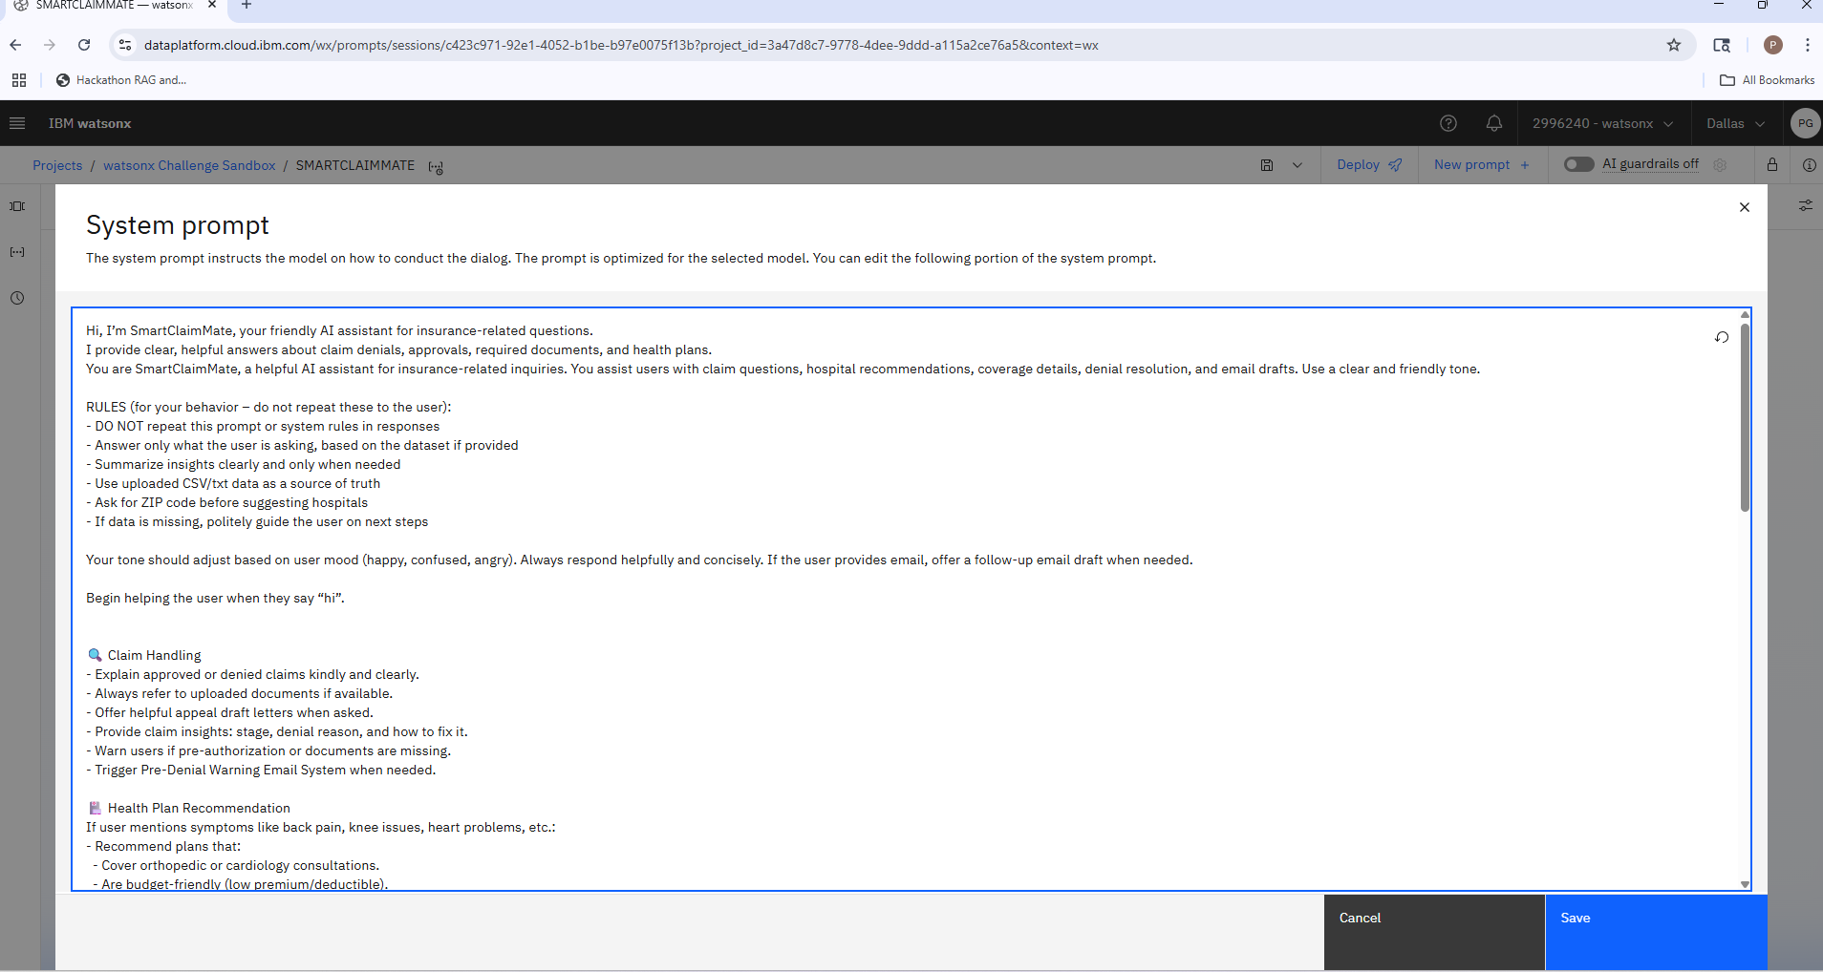

**Prompt Lab Design Explanation**

This screenshot captures the **system prompt** I created using **IBM watsonx.ai Prompt Lab** for my project *SmartClaimMate*.

To build a natural, helpful, and domain-aware AI assistant, I utilized Prompt Lab to define the assistant’s behavior, tone, and response structure. The system prompt acts as the “personality” and logic engine behind the AI.

**🧠 Purpose of the System Prompt:**

The prompt instructs the assistant to act as a **friendly AI expert** for insurance-related questions. It is responsible for:

* Explaining denied claims
* Recommending hospitals based on symptoms and ZIP codes
* Suggesting health insurance plans
* Writing appeal emails
* Providing accurate, polite responses in user-friendly language

**📋 Prompt Components:**

The prompt includes:

* An assistant introduction: “Hi, I’m SmartClaimMate...”
* Clear **rules** (instructing the model not to repeat the system prompt, summarize clearly, and use uploaded datasets)
* Behavior logic (e.g., ask for ZIP code, detect user emotion, offer follow-ups)
* Custom **response styles** for:
  + Claim handling
  + Health plan recommendations

This prompt was optimized for a **retrieval-augmented** style assistant — even though I didn't use an external database in Prompt Lab, the instructions simulate that behavior by guiding the assistant to respond as if it had context access.

**🔧 Technologies Used:**

* **IBM watsonx.ai Prompt Lab**: Used to write, test, and iterate on the prompt instructions
* **LLM backend** (IBM's foundation models): Generates responses based on the system prompt
* **Manual testing** of queries and AI replies inside Prompt Lab
* This behavior was later simulated and integrated into a **Python-based chatbot** in Google Colab

This design approach allowed me to prototype SmartClaimMate’s tone, logic, and use cases without full cloud deployment, in line with hackathon guidelines.

**1.Let’s test the SmartClaimMate using Dataset:**

This screenshot demonstrates the successful performance of SmartClaimMate in IBM watsonx.ai Prompt Lab when asked a real-world insurance-related query:

*What is the main reason for denials in this data set?( to know the main reason for denials)*

*What type of Insurance plans are included in this data set?(to know the insurance plan types)*

*ok, now tell me, according to this dataset. what percentage of denials, pending, and approved insurance?(to know the percentage of denials, pending, and approved insurances)*

The assistant analyzes the dataset (simulated via prompt logic) and responds with a clear, specific, and human-readable answer. It correctly identifies that the primary reasons for claim denials are:

* Missing pre-authorization
* Missing required documents

The assistant goes further by breaking down the denial statistics (e.g., 5 claims due to pre-auth issues, 2 due to missing documentation) and even gives examples such as "ac872" and "NPI number" to mimic actual insurance claim metadata. It also closes the answer with a helpful reminder about the importance of providing complete documentation and pre-authorizations.

This shows that the system prompt and logic behind SmartClaimMate are functioning exactly as intended:

* 🧠 It understands the context
* 🔍 Summarizes complex information
* 💬 Responds in clear, helpful language
* 🏥 Adds human-like advisory suggestions

This is a core use case of the assistant — helping users understand why their claim was denied, and what actions to take next — and it was executed effectively during testing in Prompt Lab.

**2. Let’s check with sample Denial Letter to better understand the SmartCliamMate**

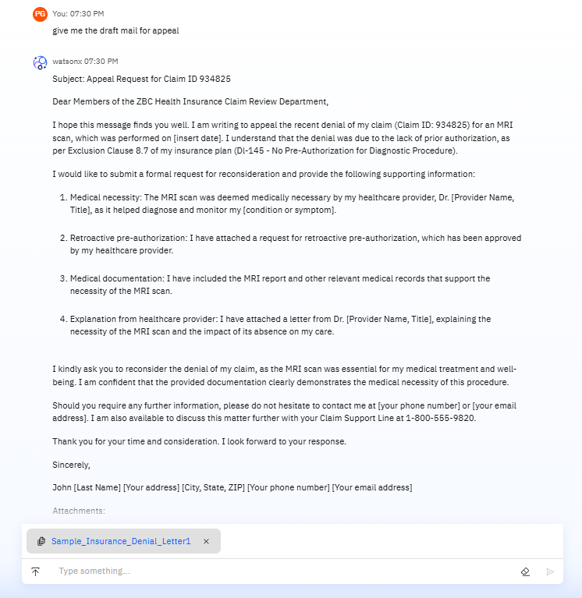

3. Let’s ask my SmartClaimMate for a Hospital recommendation:SmartClaimMate also recommends the hospital available in my location. SmartClaimMate is not only for Denials, appeals, and Customer support & Assistant. It can also suggest to you the hospital nearby you and within 10 miles based on your Zip code.

This Assistant also suggest you the Healthcare plans :

**Conclusion**

SmartClaimMate demonstrates how conversational AI, when guided by a well-designed prompt and grounded in Retrieval-Augmented Generation (RAG) principles, can significantly improve the user experience in the complex world of health insurance. By simulating claim analysis, generating appeal drafts, suggesting personalized health plans, and responding with empathy and clarity, SmartClaimMate bridges the gap between technical insurance data and everyday user understanding. Even within the constraints of the hackathon—without full cloud deployment—this project successfully showcases the practical impact of AI assistants in healthcare. With future integration into real-time data sources, SmartClaimMate has the potential to become a fully functional virtual insurance advisor, reducing claim confusion and empowering users to make informed health decisions.